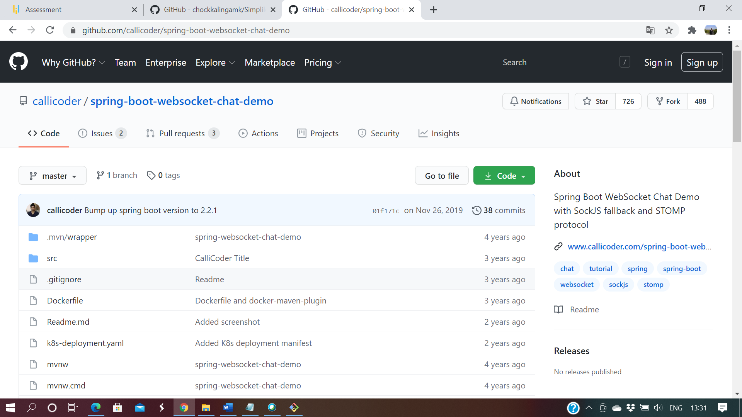

1. Login into the Lab VM and open the terminal

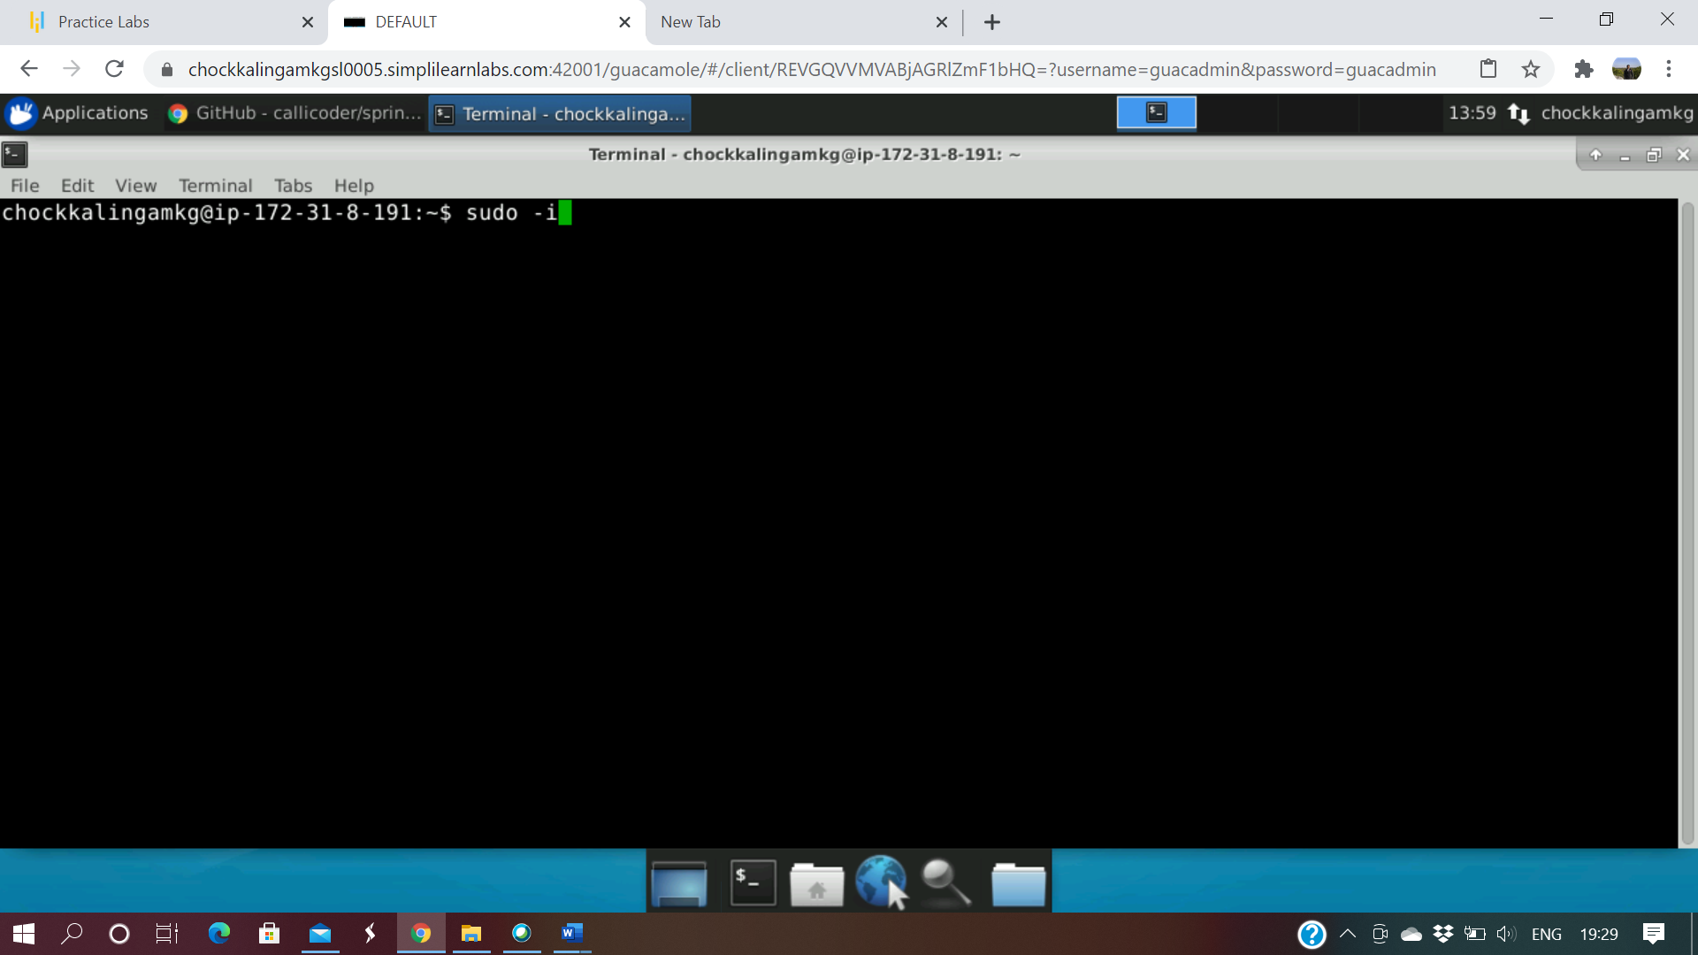

1. Provide sudo -i to give the administrator access to do the comments

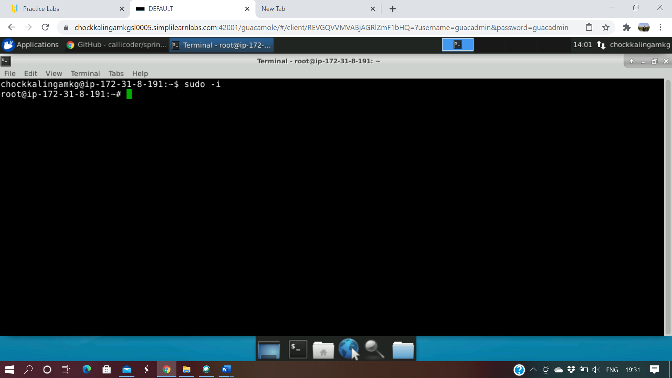

1. Open the Jenkin to create project for getting from the GITHub and build it with maven and with help docker create an image

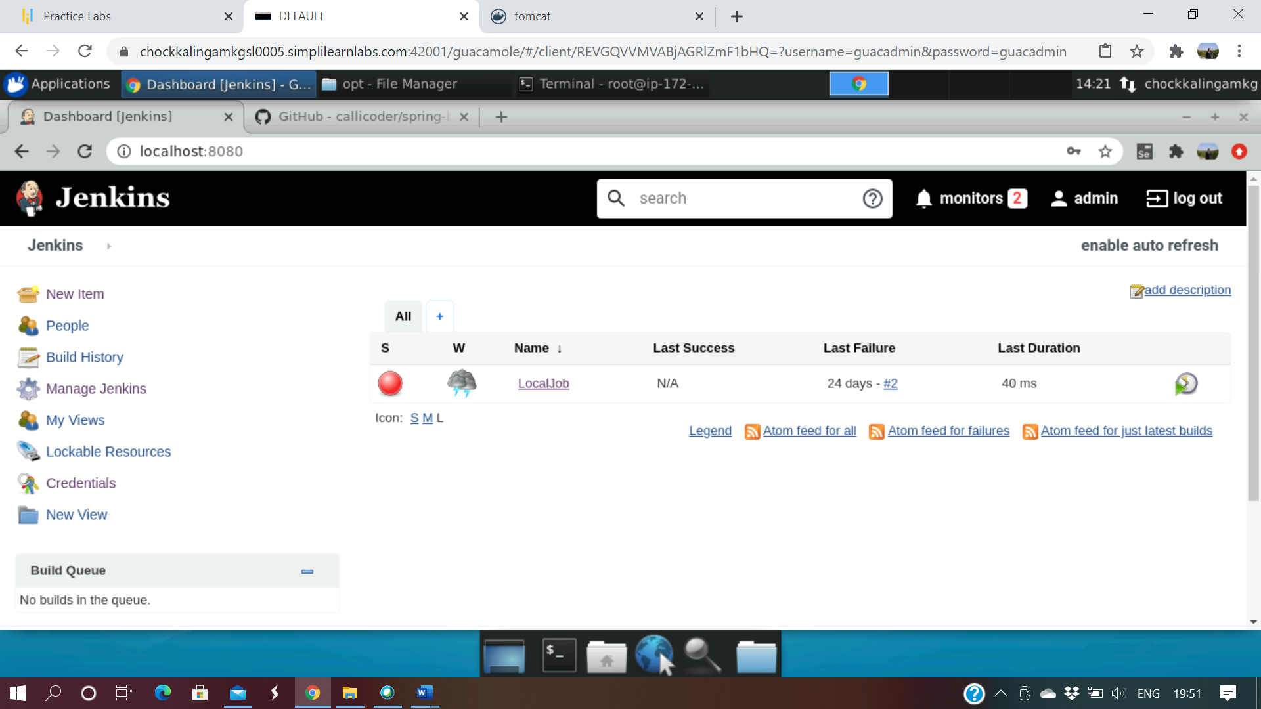

1. Go to the Manage plugin and select the docker and select the install without restart option

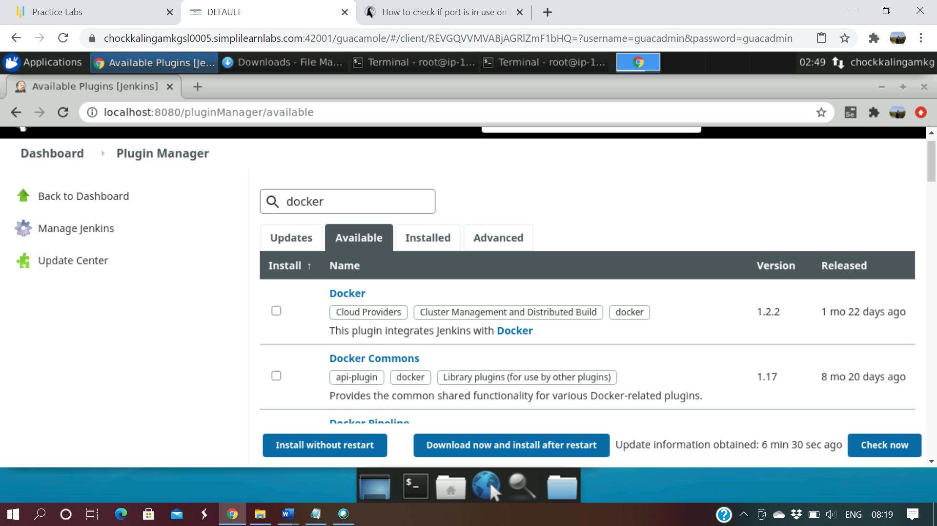

1. Docker installation is in progress

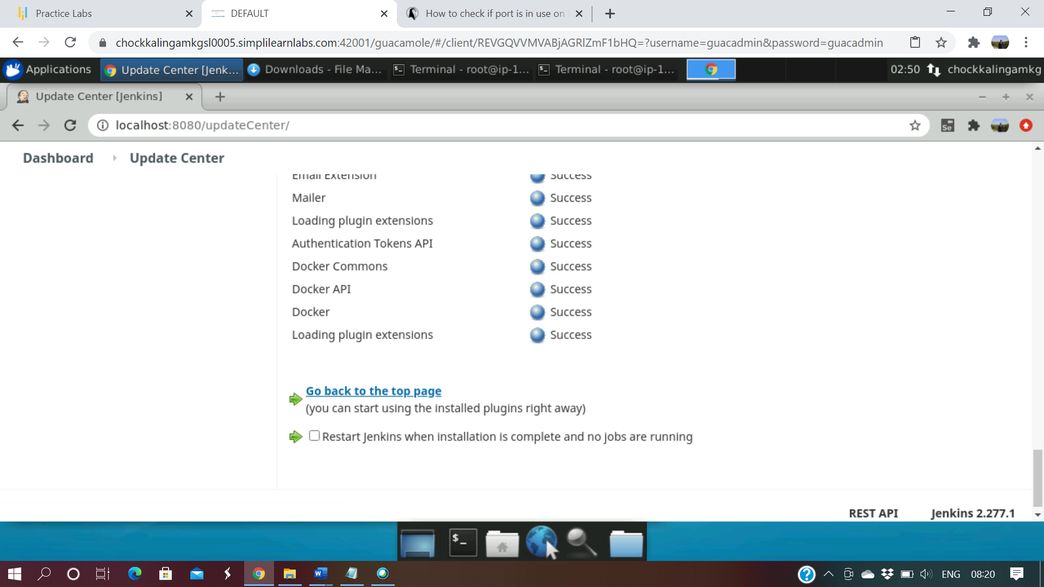

1. Go to the Manage Jenkins and system configuration for configure system

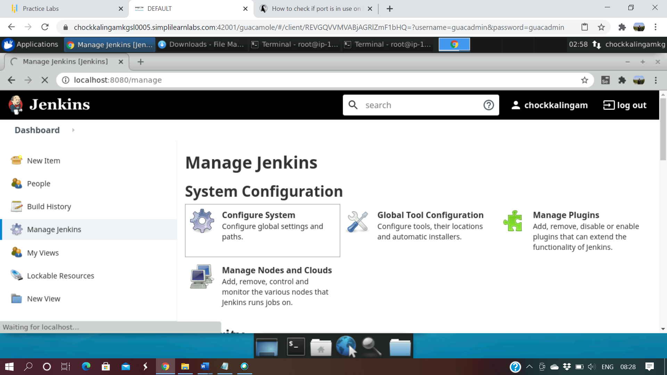

1. Go to the bottom line and select cloud option

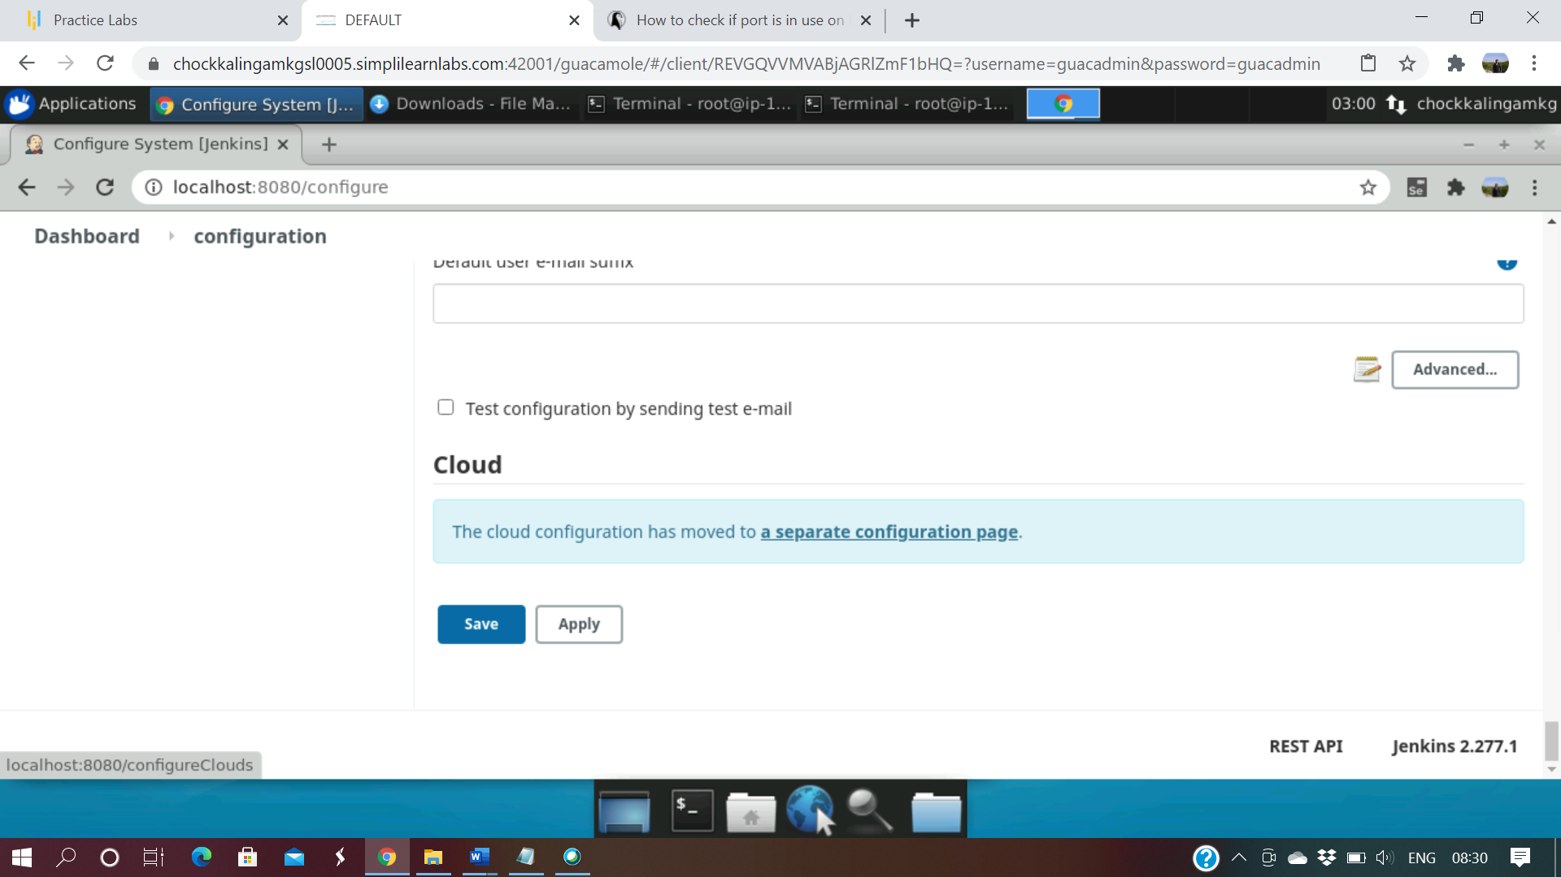

1. Inside Docker configure file provide the name and click docker details and click save

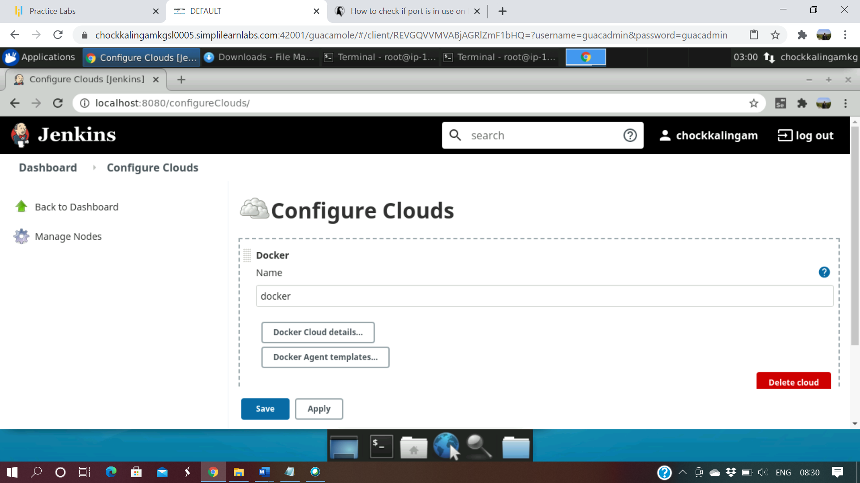

1. We can configure Maven by going to Manage plugin >> Global Configuration

And provide the necessary details

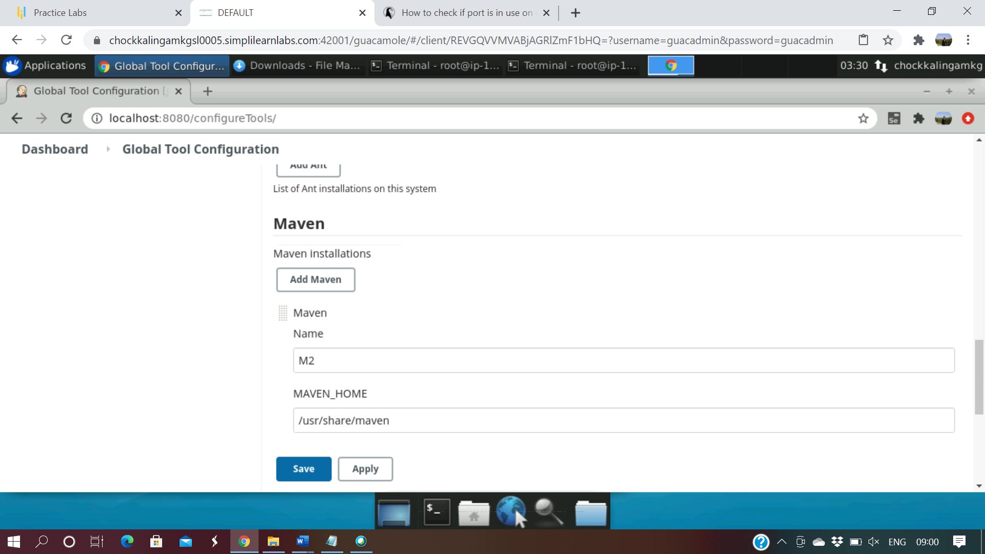

1. Give a new name as “docker” and select the ‘Freestyle project’

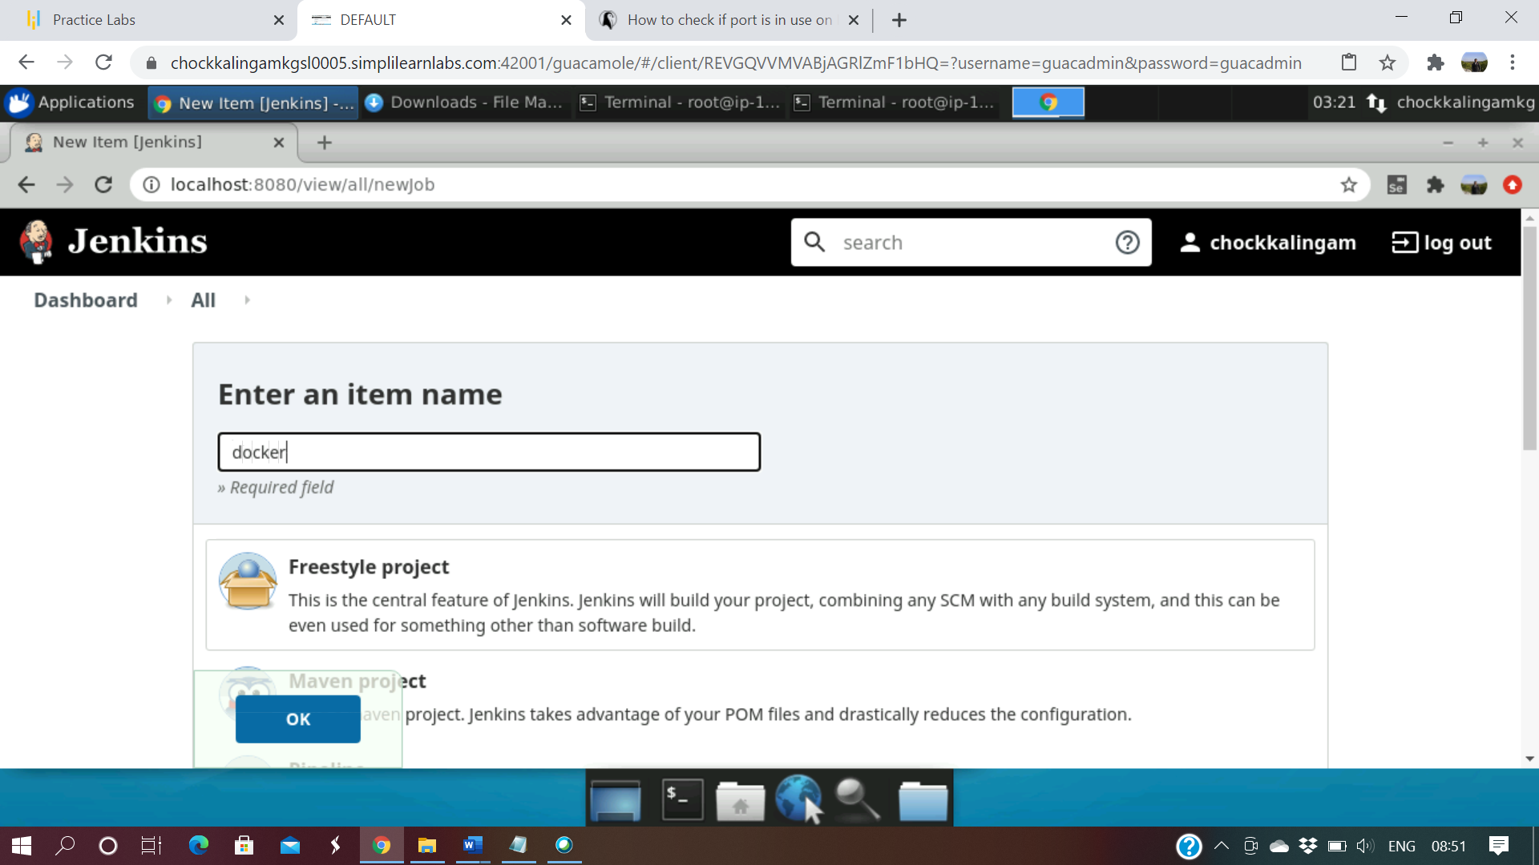

1. Select the Source Code Management tab and GIT option and provide the GIT URL

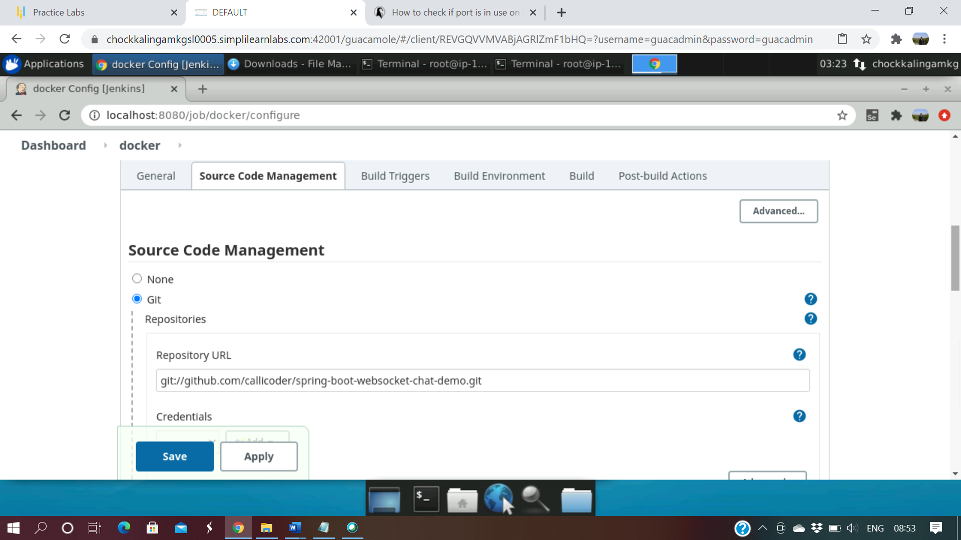

1. Select “Build” steps and select the option “Invoke top-level maven targets” and provide the option “clean package”

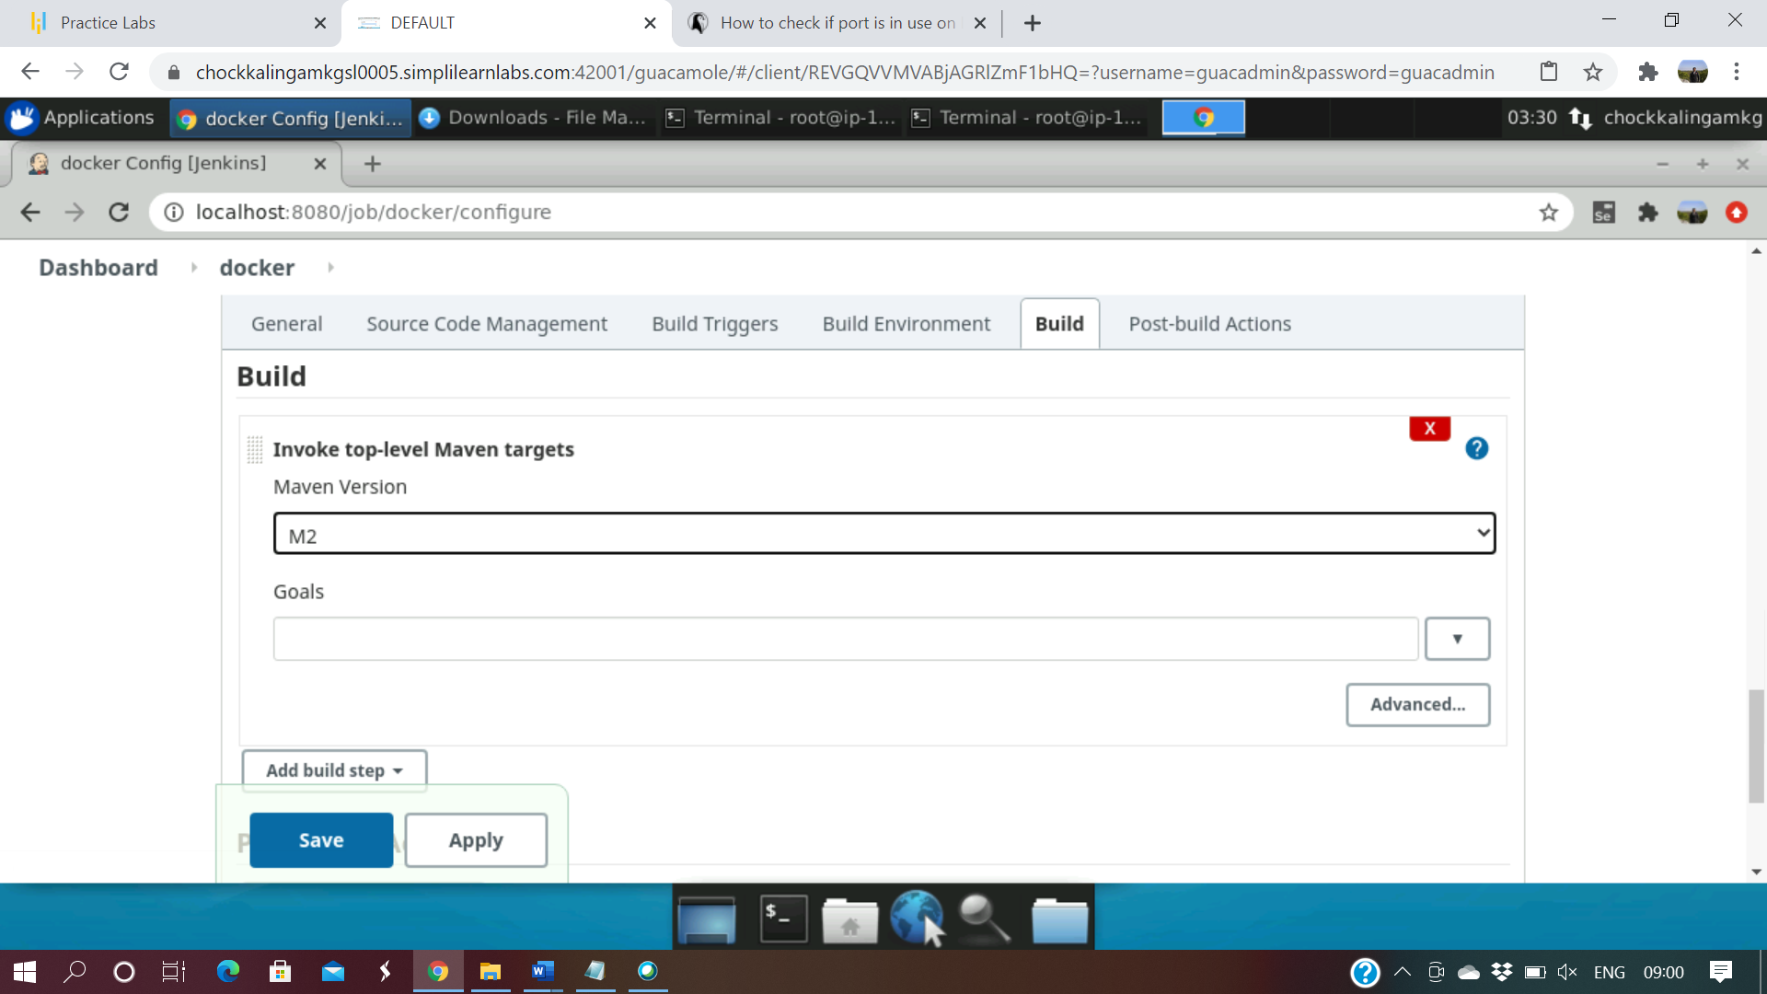

1. Add one more build setup “Build docker image” and select the docker cloud and image name.

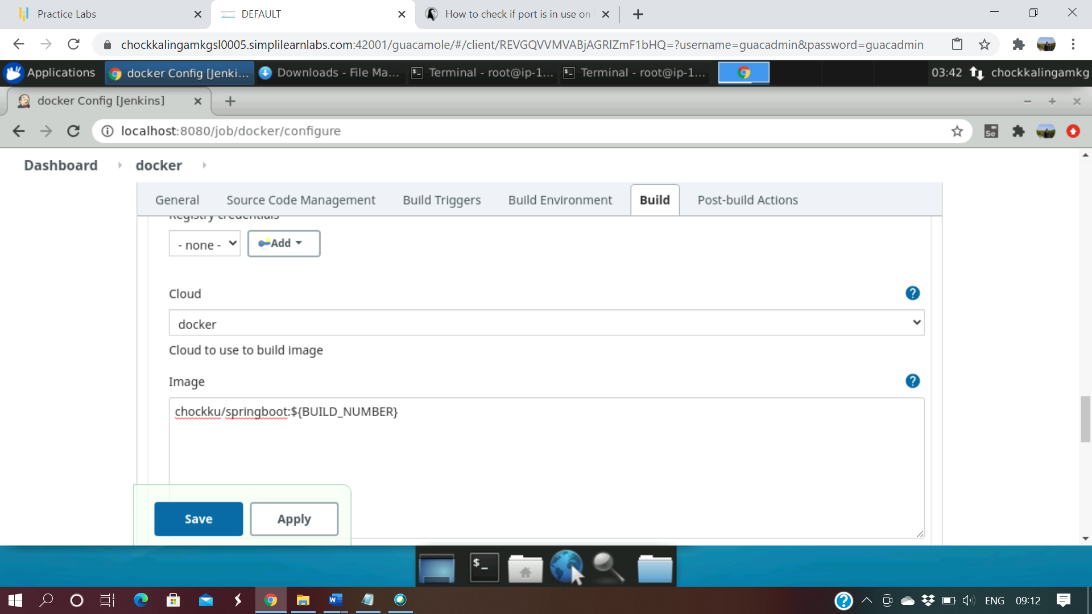

1. Add one more build step with execute shell and provide the docker steps.

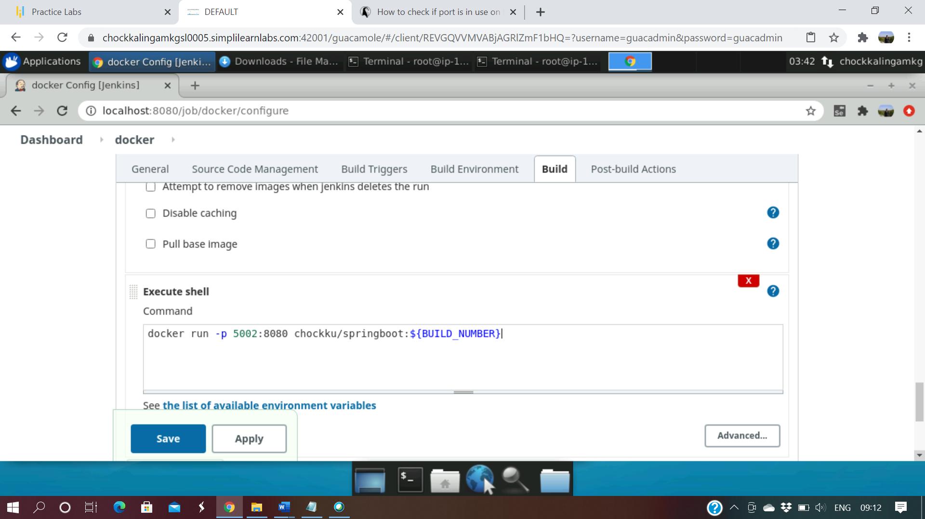

1. Click on the build step to execute build.

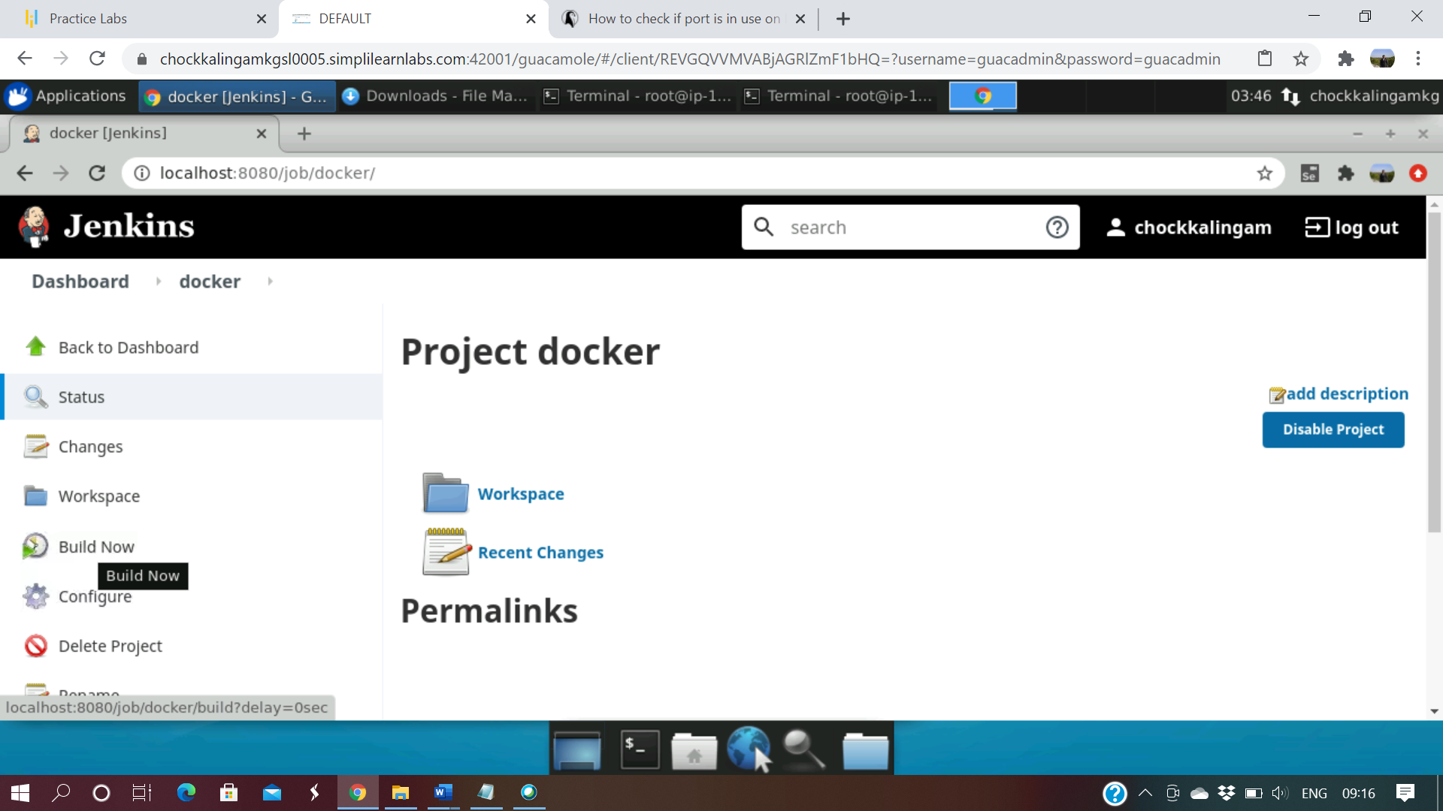

1. Step by step build compilation steps

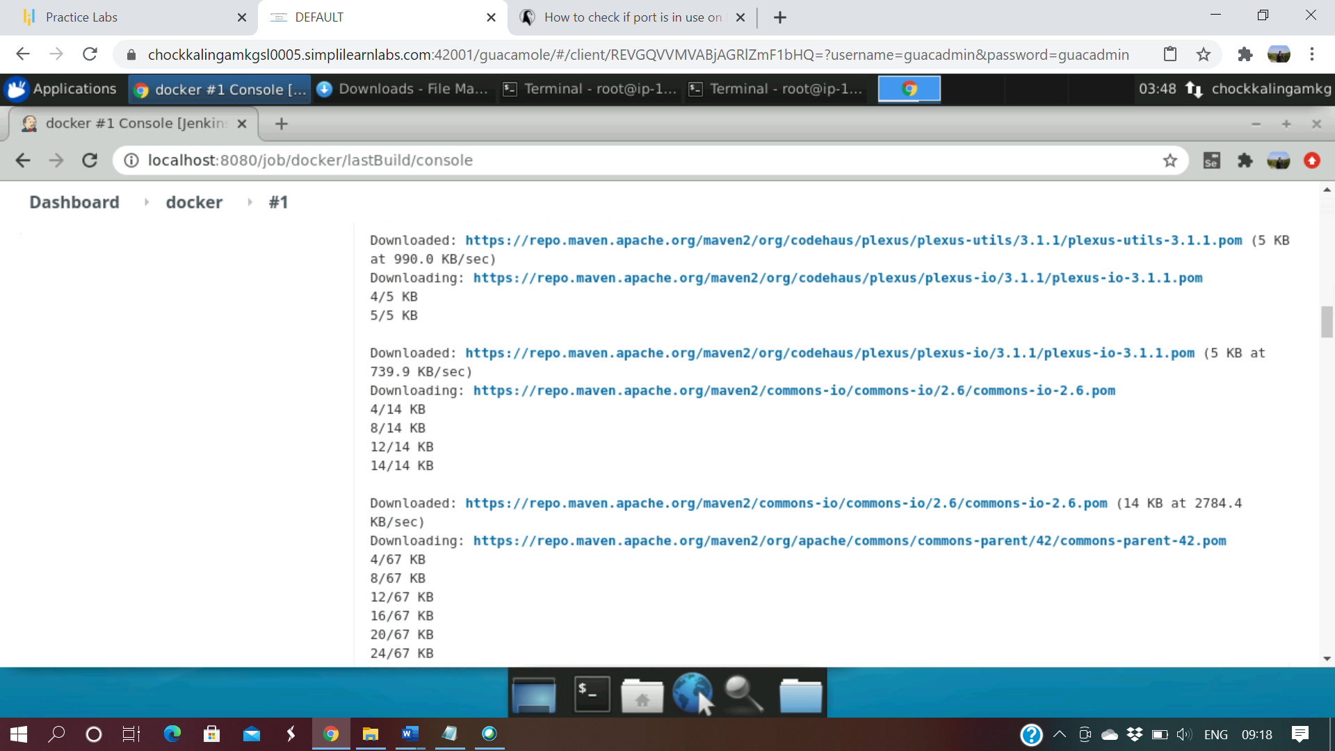

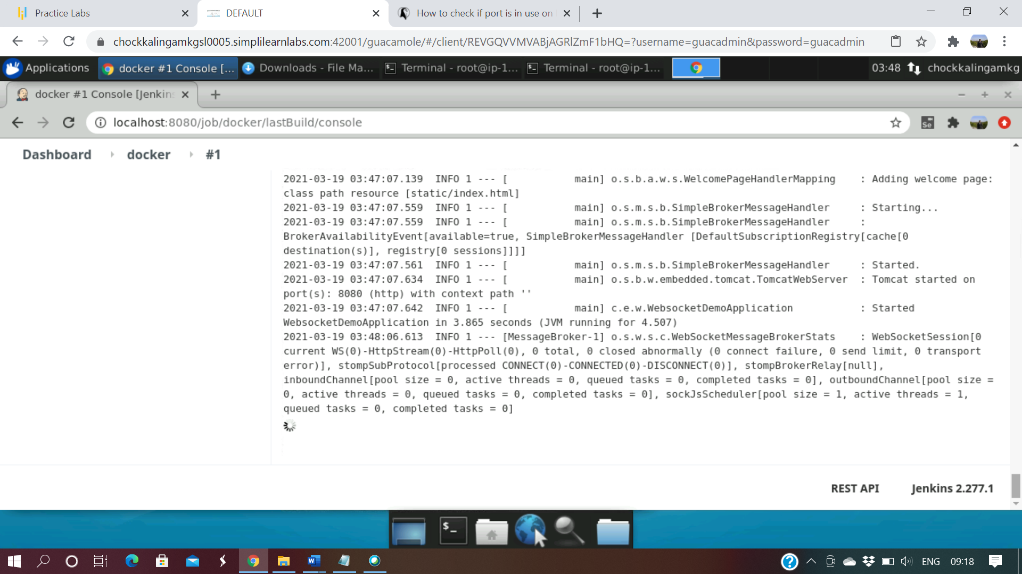

1. Once the build is completed a web application would be launched and access it through a URL “localhost:5002”

